Hi Esther,

The below observations are on data discrepancies. The impact is information in Coswin not transformed correctly in Maximo, relevant transactional records not displayed, affecting accuracy of record and report generation.

These need to be rectified in next migration.

And the checking is still in progress.

Observation date: 25/03/2025

Verified with Wei Teng, Esther

Checked in Production Platform loaded with latest Coswin dataset dated 19/03/2025:

1. Coswin Hazardous item not checked in Item Master. Coswin Item code: LRT-ISOPROPYL-A. Maximo Item Code: B10-CTK1-0001-0280A1

DONE. PREVIOUSLY NOT MIGRATED.

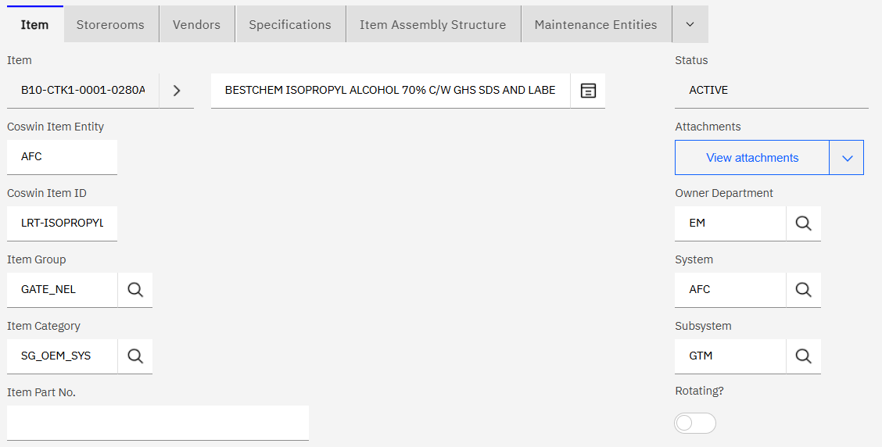

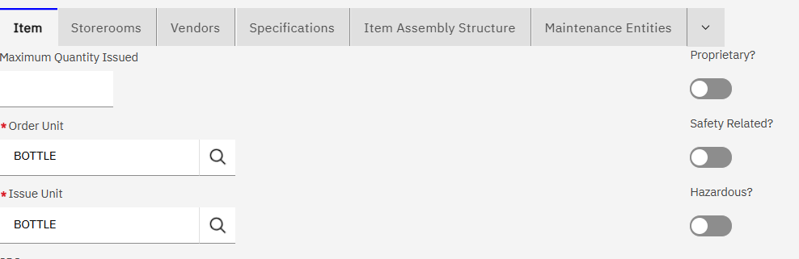

1. TEMP item in Coswin should map to status 'INACTIVE' in Maximo - Item Master  
     
   DONE => now TEMP item, status = ‘PLANNING’

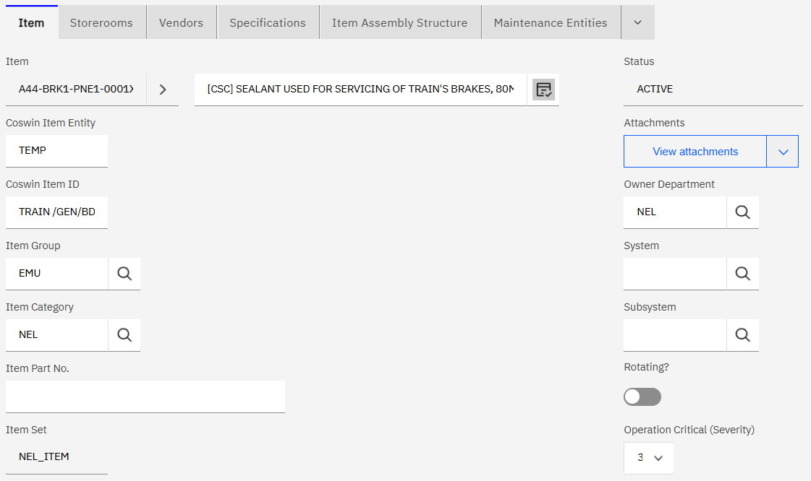

1. Item Type should display the whole text (Repairable, Non-Repairable), not the code NR.

DONE

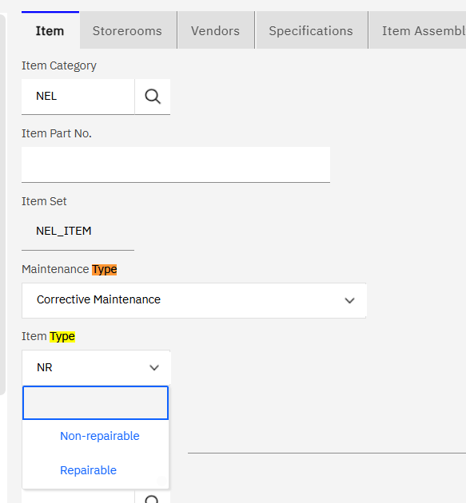

1. Item with MSDS description in Coswin is not mapped to Maximo Item Master - SDS field. The report, "list of hazardous items" need to use the SDS field to do checking.

NOT CLEAR WHAT IT MEANS?

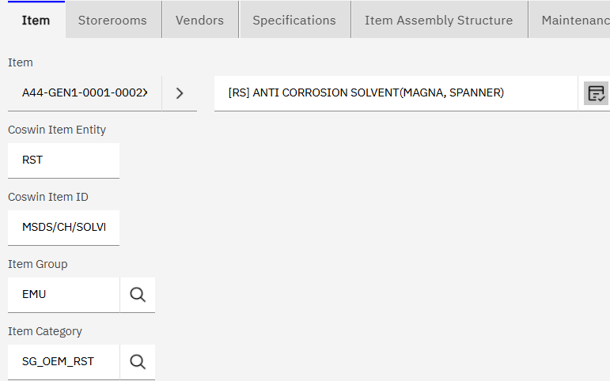

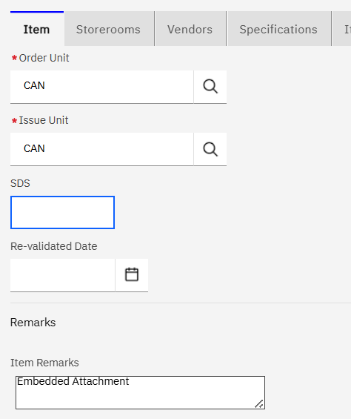

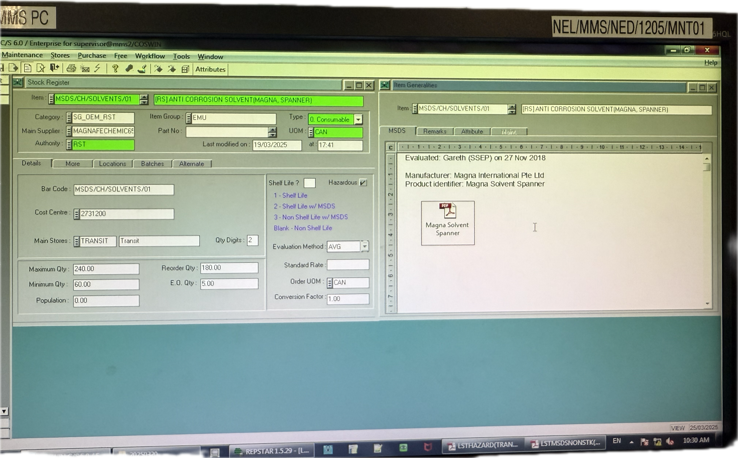

1. PR - PL25/0062, it is Status 4 - under quotation in Coswin, but in Maximo, it show Cancelled.

THE CURRENT MAPPING IS INDEED : CANCEL. WHAT IS THE CORRECT MAPPING? DONE. SET TO APPR

1. 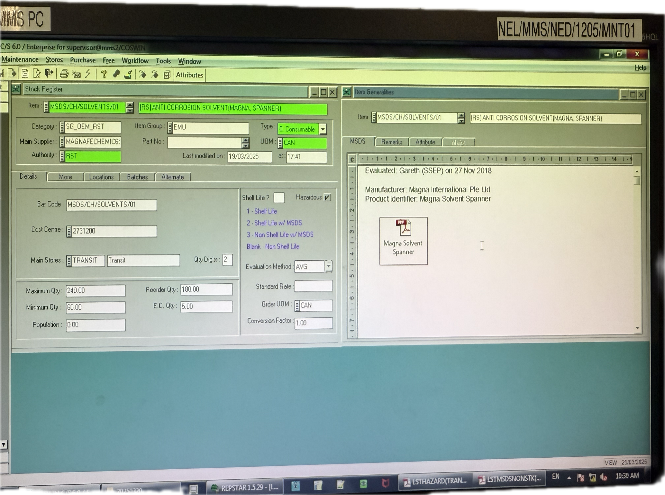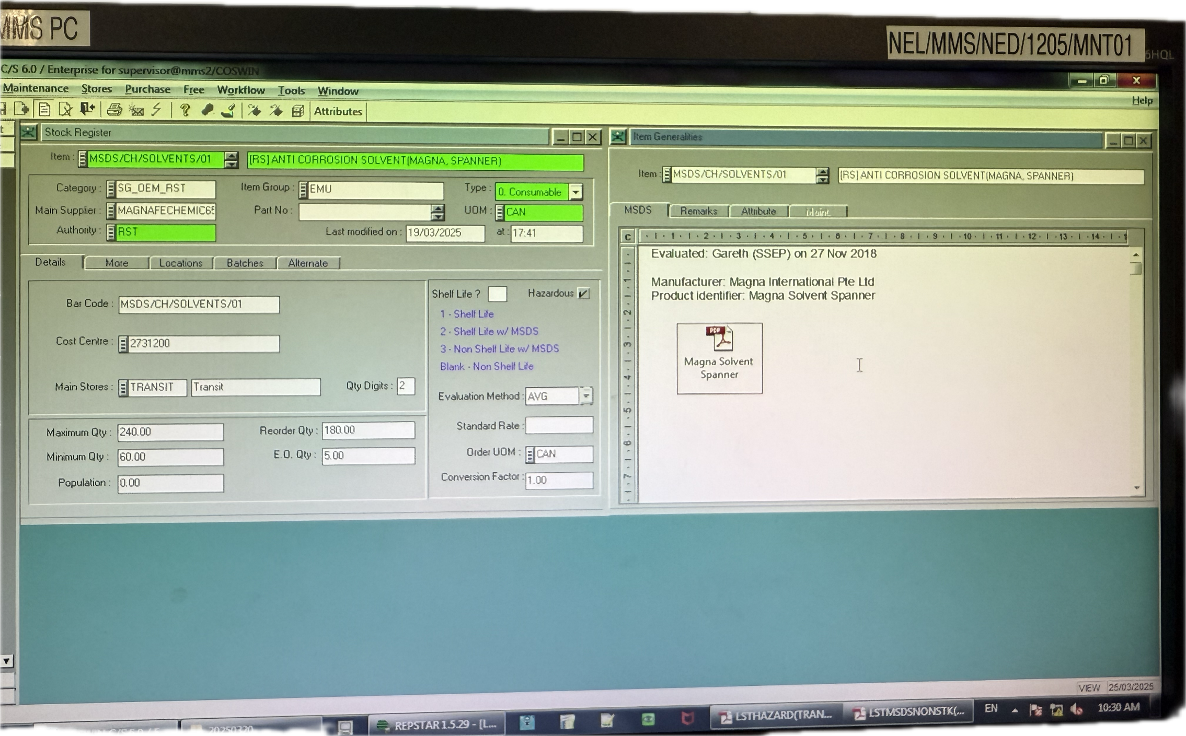

WHAT IS THE ISSUE?

1. PR - PL25/0040, in Coswin it is Status 4 - under quotation, in Maximo, is show cancelled. And there's no RFQ number under Related Records.

THIS IS BECAUSE STATUS OF PR IS ‘CANCEL’ AND BECAUSE THE MULTI RFQ RELATIONSHIP. IF THE PR STATUS IS FIXED, IT SHOULD BE FIXED. DONE

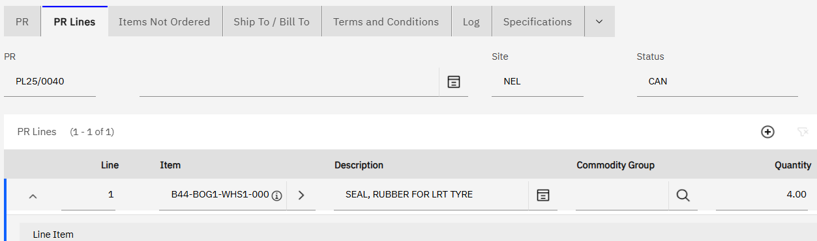

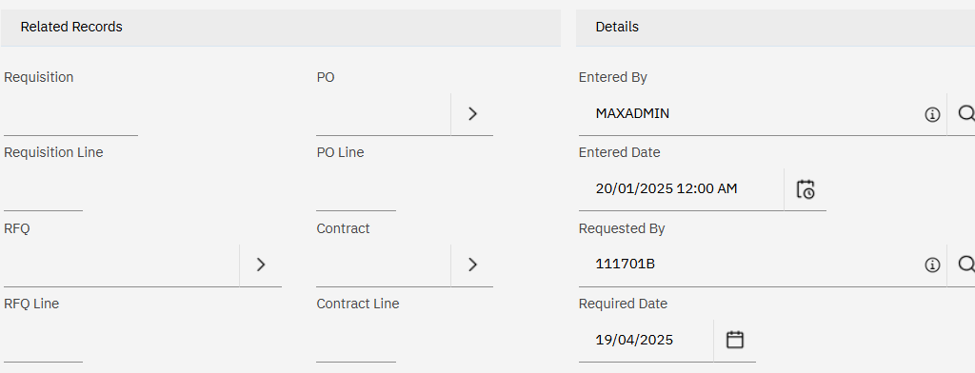

1. In Coswin, there is a quotation KO04594525001 related to the PR.

DONE

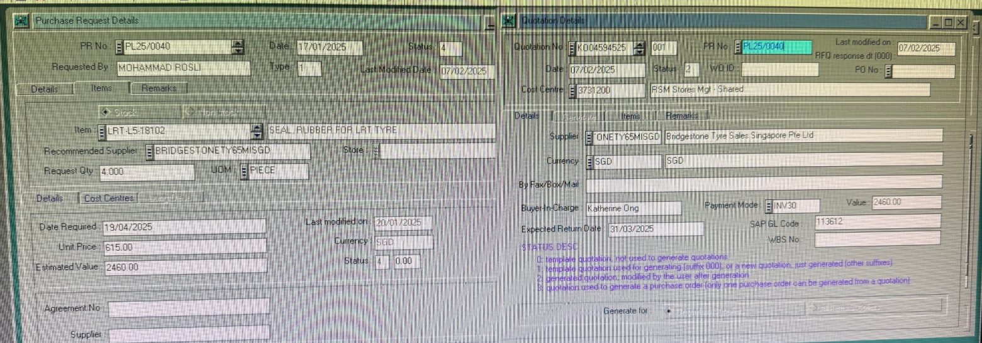

1. When trying to download Item Master from list view (abt 12k records), the tab of loading the item master download will close off automatically after a while.

SOFTWARE ISSUE.

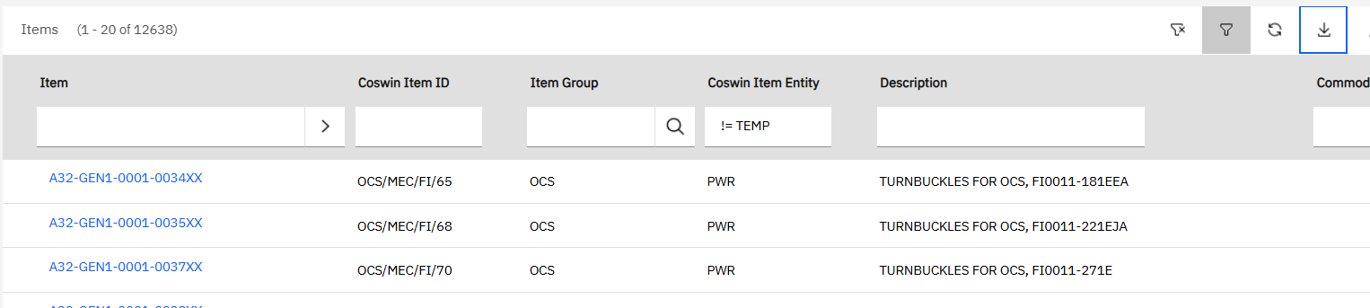

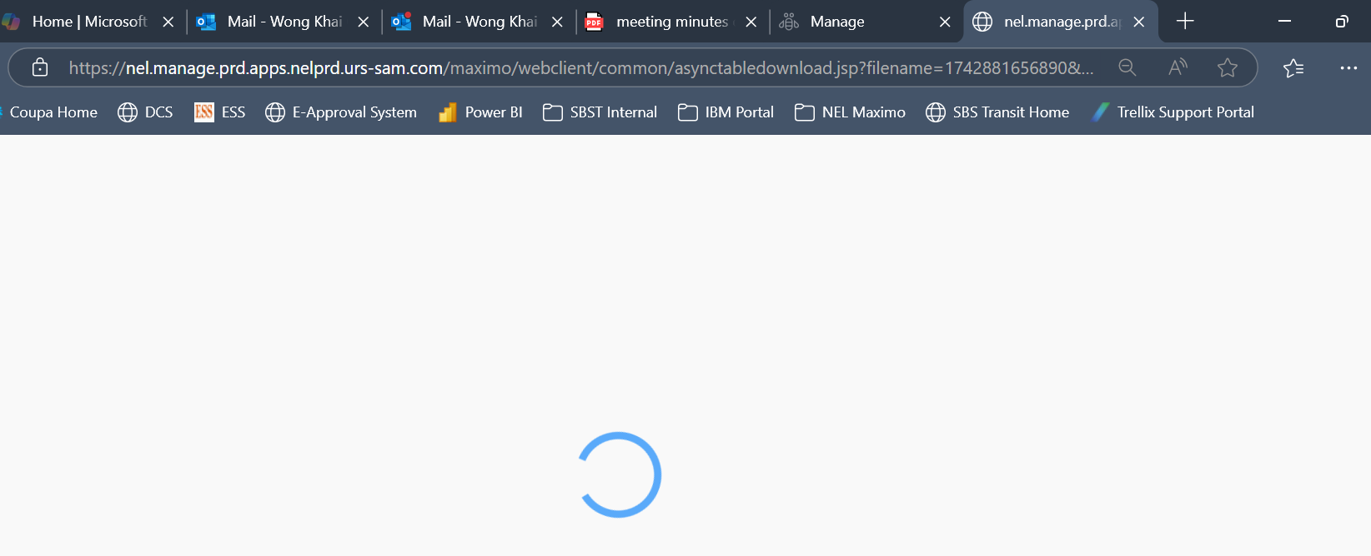

1. But if right click the 'Download' button and choose open in New Tab, then can download.

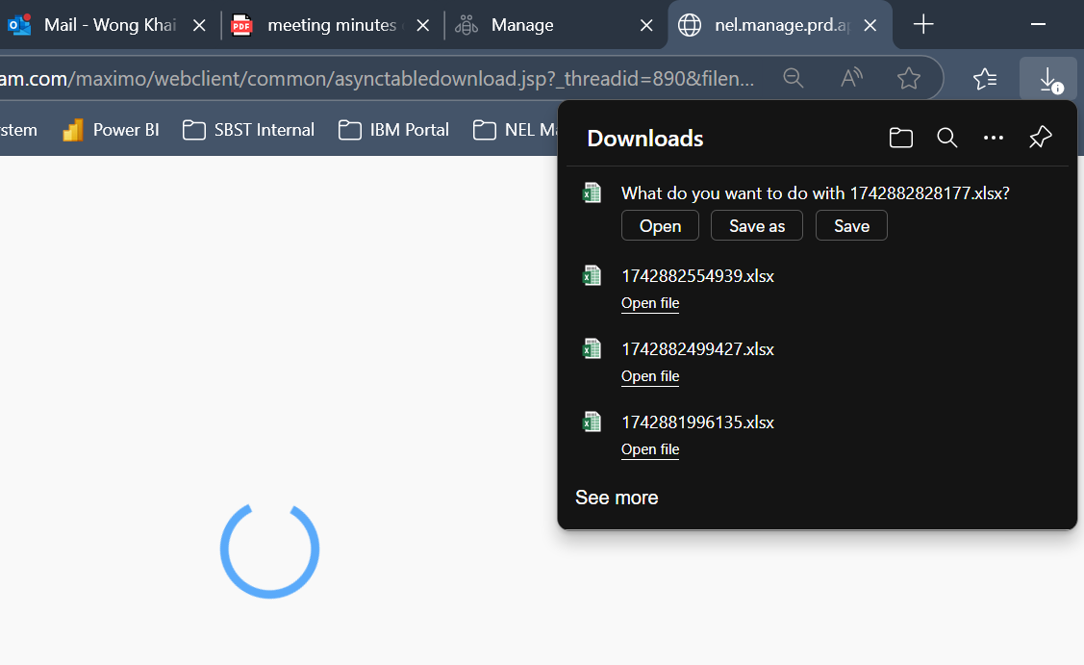

1. When trying to download asset list view, filter entity AFC, about 8900 records, can download without issue. Pls check if there setting that is affecting the download. Users download data very frequently.
2. Inventory List View must have at least the same columns as Item Master, e.g. Maintenance Entity, Department, Item Group, etc.

SOFTWARE ISSUE

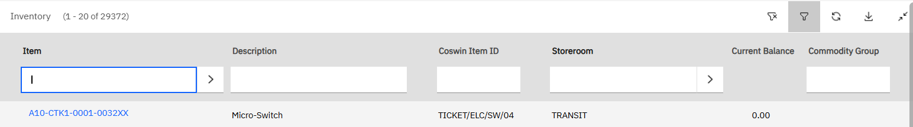

1. Inventory, Item S/EL/FLUO_TUBE/02, in Coswin, MAP is 1.88, Receipt Price is 1.90. But in Maximo, the Actual Cost is zero, standard cost is 1.80, Last receipt cost is 1.89999. All wrong.

NEED TO CHECK

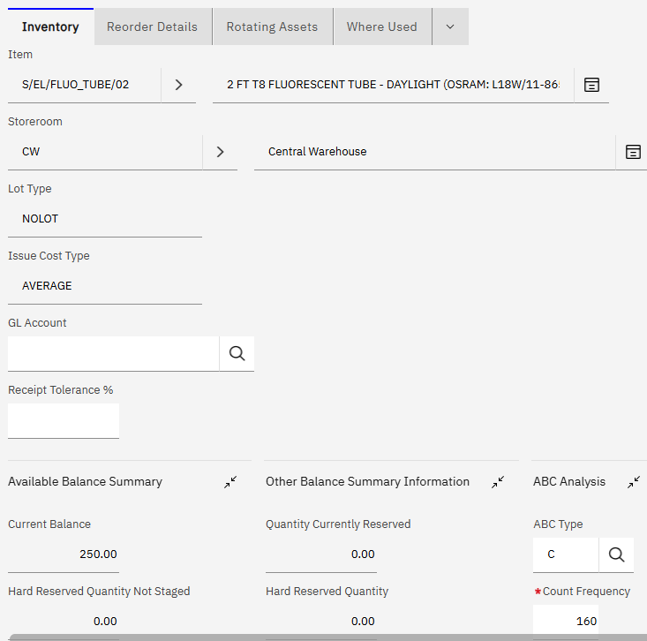

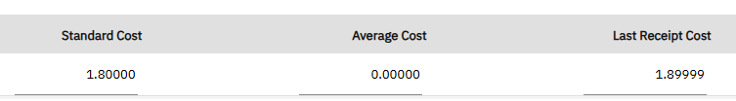

1. WO 1087460, in Coswin WO - Stock, there are 2 items issued from DEM99943. But in Maximo, the 2 items are displayed only under WO - Plan - Material, not under WO - Actual - Material.

NEED TO CREATE NEW MIGRATION PKG! DONE

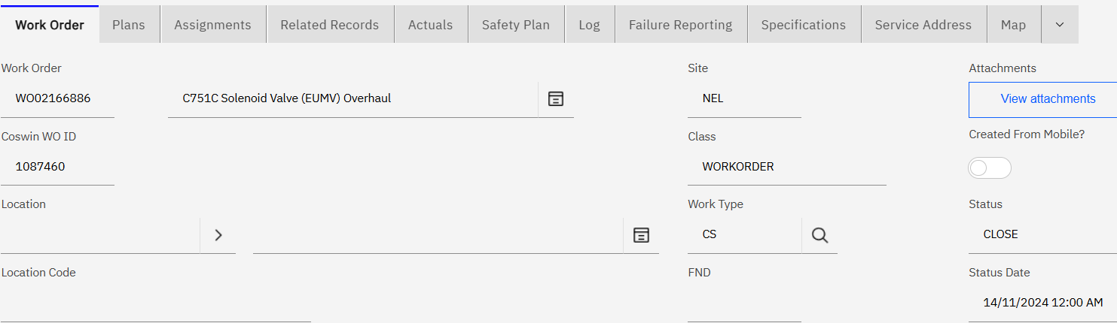

1. 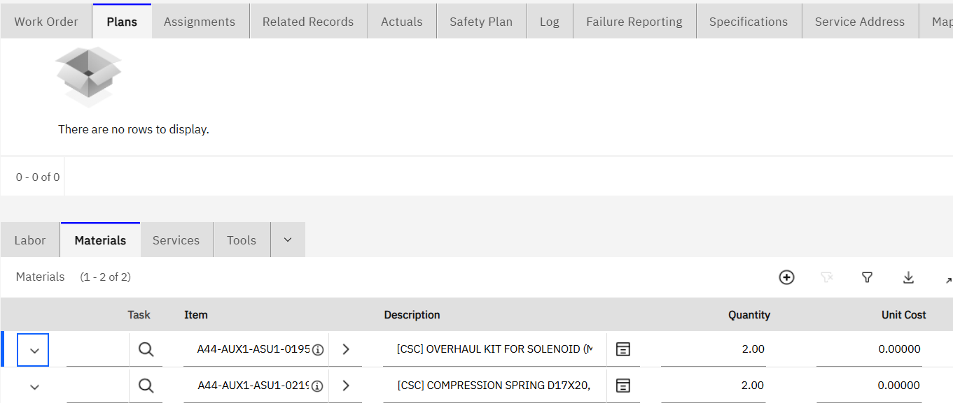
2. 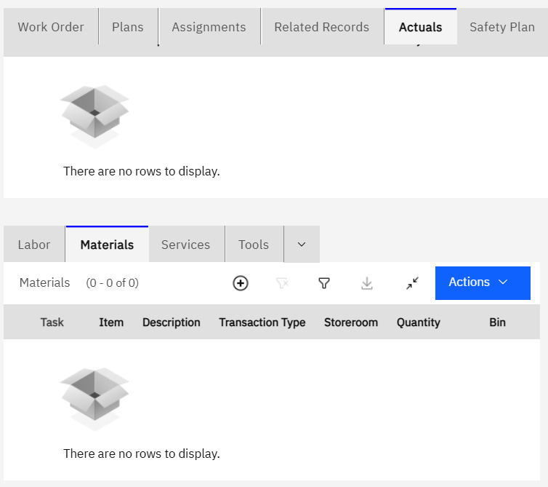

Best Regards,

Khai Chin

SBS Transit Rail Pte Ltd

Asset Management (AM)

91 Sengkang East Ave  
Singapore 545072

DID: 64132228

This message and any attachments may contain confidential, privileged or proprietary information. If you are not the intended recipient, kindly notify us and delete this message and its attachments immediately, and please be advised that using, copying, distributing or disclosing any contents therein is not allowed. Statements pertaining to any matter outside our business are not to be taken as endorsed by ComfortDelGro Corporation Limited or its related companies. The comments/proposals provided are for discussion purposes only and are subject to approvals. Nothing herein shall constitute a binding agreement between the parties. Neither party shall be bound in any way to any term or condition except as agreed in a written agreement signed by the duly authorised representatives of both parties.   
  
ComfortDelGro - a Green Office certified by the Singapore Environment Council - is committed to preserving the environment. We encourage you to print this only if necessary.   
  
SBS Transit Ltd [Registration No. 199206653M]